Staplehurst Parish Council
Section 137 Grant
Application Form
Please write clearly in black or blue ink.
If you have any specific communication needs, such as preferring a LARGE PRINT VERSION, please tell us what they are – phone 01580 891761

Q1 Contact details

Name of your group or organisation
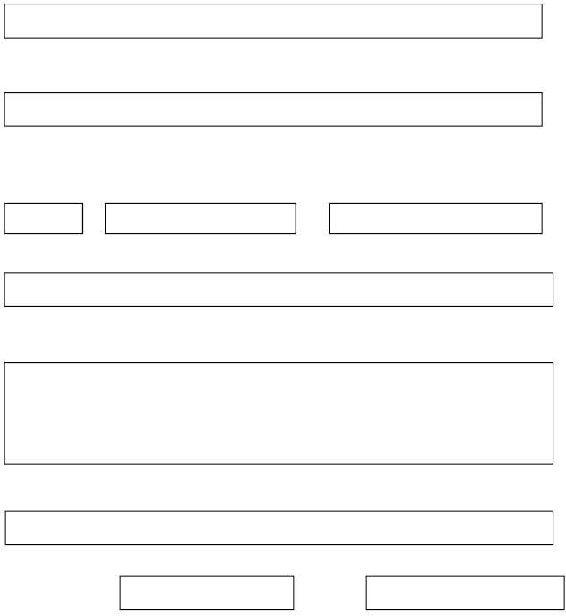
Name of your project, if this is different
Main contact for this application
Title
First name
Surname
Position held in the group or organisation
Contact address, including postcode
Postcode:
Email address
Telephone:
Day
Evening
Q2 Tell us about your group; what type of organisation are you?


Tick boxes that apply
Community Group/Club/Society

Registered Charity in England Registration number

Exempt or exempted charity registered with Inland Revenue

Other:

Q3 Briefly describe the purpose of your group/organisation.
For a new group please tell us what you intend to do or provide.

Q4 If you are a branch of, or related to, a larger organisation, please tell us which one.

Q5 Tell us about the project or activities you are planning; please be specific about what you will do and how you will do it.
Q6 What difference do you hope that the award will make to the residents of Staplehurst Parish?


Try to explain who you hope will benefit and what evidence, if any, you have to back up this view. Have you undertaken any consultation?

Q7 How many residents of the Parish of Staplehurst do you expect to benefit directly from your project/activity?
Please give a number not just ‘everyone’; an estimate is fine.

Q8 What, if any, special safety issues are related to your project or activity and how do you plan to manage these risks?
Please consider the safety of both participants and the public.

Please tick/complete boxes if your group has any of the following:

Public liability insurance Other insurance Relevant leaders’ qualifications:
Q9 Tell us the cost and how you plan to fund the activities or project;


State clearly the precise amount of money you are requesting from the Parish Council.
Costs excluding VAT

Sources of Funding and how much

Contribution from Parish Council £

Q10 What contribution either in cash, volunteer time or other resources, are you making towards the project?

Q11 Tell us if you have applied anywhere else for funding towards the work of our group or organisation in the last year.
Please indicate if the application is pending, or was unsuccessful and don’t forget to tell us whether funding was towards this project. Be sure to mention any other local councils and their response.

Q12 Provide details of current financial position
Total resources; savings (cash, reserves and investments) at date of application.
New groups will need to fill in savings and expenditure even if it is a ‘nil’ return.

£

Total annual expenditure from your most recent accounts

£
Check List

Please tick:

We have answered all the questions on the form.


We have enclosed a summary or copy of the Accounts for the last two years OR for new groups a budget forecast for the forthcoming / current year.

We have enclosed a up to date copy of Insurances

A senior officer from the organisation has signed the form.

Declaration

To be signed by a senior officer from your organisation.
The information provided is correct to the best of my knowledge.
I have read and understand the conditions under which any award may be given.
I understand that the award may become repayable in the event of it being used for purposes other than specified, or the organisation ceases to operate.

I agree to provide evidence (photographs if possible) that can be used by the Council for publicity, or in any way it so wishes, to show that the award has been used for the approved purpose.

Signed ………………………………………………………………………….. Date………………..…………………..

Position held …………………………………………………………………

Please return to:

Deborah Jenkins
Staplehurst Parish Council
Staplehurst Community Centre,
High Street,
Staplehurst
Tonbridge
Kent
TN12 0BJ
Data Protection Statement:

The information collected by Staplehurst Parish Council on this form and from supporting evidence will be used to process your application.

We may check information provided by you, or information about you provided by a third party, with other information held by us. We may also get information from certain third parties, or give information to them to check the accuracy of information, to prevent or detect crime, or to protect public funds in other way, as permitted by law. These third parties may include Government Departments and Local Authorities.

We will not disclose information about you to anyone outside Staplehurst Parish Council, nor use information about you for other purposes unless the law permits us to.

Please do not write anything below this line

Award Given

Date
£

…………………………..……………………..



Special conditions if any …………………………………………………………………………………………………………………………….….

………………………………..……………………………………………………………………..……………………………………

